HANDS-ON 5 : Reactive Forms — FormBuilder, FormGroup, FormArray & Custom Validators
Project Structure:
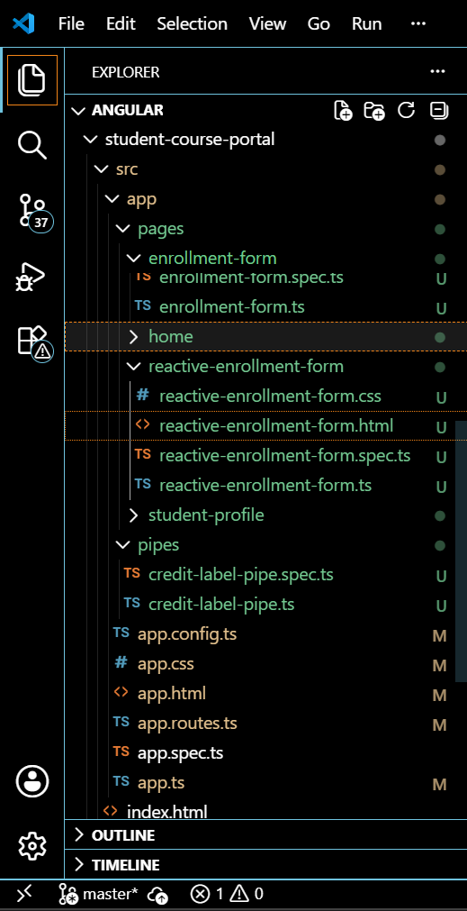
Reactive-enrollment-form.html
<form [formGroup]="enrollForm" (ngSubmit)="onSubmit()">

<div class="field">
<label>Student Name</label>
<input type="text" formControlName="studentName" />
<span *ngIf="enrollForm.get('studentName')?.touched && enrollForm.get('studentName')?.errors?.['required']">
Name is required.
</span>
<span *ngIf="enrollForm.get('studentName')?.errors?.['minlength']">
Name must be at least 3 characters.
</span>
</div>

<div class="field">
<label>Student Email</label>
<input type="email" formControlName="studentEmail" />
<span *ngIf="enrollForm.get('studentEmail')?.pending">
Checking email availability...
</span>
<span *ngIf="enrollForm.get('studentEmail')?.errors?.['required']">
Email is required.
</span>
<span *ngIf="enrollForm.get('studentEmail')?.errors?.['email']">
Please enter a valid email.
</span>
<span *ngIf="enrollForm.get('studentEmail')?.errors?.['emailTaken']">
This email is already taken.
</span>
</div>

<div class="field">
<label>Course ID</label>
<input type="text" formControlName="courseId" />
<span *ngIf="enrollForm.get('courseId')?.errors?.['required']">
Course ID is required.
</span>
<span *ngIf="enrollForm.get('courseId')?.errors?.['noCourseCode']">
Course code starting with XX is not allowed.
</span>
</div>

<div class="field">
<label>Preferred Semester</label>
<select formControlName="preferredSemester">
<option value="Odd">Odd</option>
<option value="Even">Even</option>
</select>
</div>

<div class="field">
<label>
<input type="checkbox" formControlName="agreeToTerms" />
I agree to the terms
</label>
</div>

<div formArrayName="additionalCourses">
<h4>Additional Courses</h4>
<div *ngFor="let ctrl of additionalCourses.controls; let i = index">
<input [formControlName]="i" placeholder="Course code" />
<button type="button" (click)="removeCourse(i)">Remove</button>
</div>
<button type="button" (click)="addCourse()">Add Another Course</button>
</div>

<button type="submit" [disabled]="enrollForm.invalid">Submit</button>
</form>

Reactive-enrollment-form-spec.ts
import { ComponentFixture, TestBed } from '@angular/core/testing';

import { ReactiveEnrollmentForm } from './reactive-enrollment-form';

describe('ReactiveEnrollmentForm', () => {
let component: ReactiveEnrollmentForm;
let fixture: ComponentFixture<ReactiveEnrollmentForm>;

beforeEach(async () => {
await TestBed.configureTestingModule({
imports: [ReactiveEnrollmentForm]
})
.compileComponents();

fixture = TestBed.createComponent(ReactiveEnrollmentForm);
component = fixture.componentInstance;
fixture.detectChanges();
});

it('should create', () => {
expect(component).toBeTruthy();
});
});

Reactive-enrollment-form.ts
import { Component, OnInit } from '@angular/core';
import { CommonModule } from '@angular/common';
import { ReactiveFormsModule } from '@angular/forms';
import {
FormBuilder,
FormGroup,
FormArray,
Validators,
AbstractControl,
ValidationErrors
} from '@angular/forms';

// ---------- Step 53: Custom synchronous validator ----------
export function noCourseCodeValidator(control: AbstractControl): ValidationErrors | null {
const value: string = control.value || '';
if (value.toUpperCase().startsWith('XX')) {
return { noCourseCode: true };
}
return null;
}

@Component({
selector: 'app-reactive-enrollment-form',
standalone: true,
imports: [CommonModule, ReactiveFormsModule],
templateUrl: './reactive-enrollment-form.html',
styleUrls: ['./reactive-enrollment-form.css']
})
export class ReactiveEnrollmentForm implements OnInit {

enrollForm!: FormGroup;

constructor(private fb: FormBuilder) {}

ngOnInit(): void {
this.enrollForm = this.fb.group({
studentName: ['', [Validators.required, Validators.minLength(3)]],
studentEmail: [
'',
[Validators.required, Validators.email],
[this.simulateEmailCheck.bind(this)]
],
courseId: [null, [Validators.required, noCourseCodeValidator]],
preferredSemester: ['Odd', Validators.required],
agreeToTerms: [false, Validators.requiredTrue],
additionalCourses: this.fb.array([])
});
}

get additionalCourses(): FormArray {
return this.enrollForm.get('additionalCourses') as FormArray;
}

addCourse(): void {
this.additionalCourses.push(
this.fb.control('', Validators.required)
);
}

removeCourse(index: number): void {
this.additionalCourses.removeAt(index);
}

simulateEmailCheck(control: AbstractControl): Promise<ValidationErrors | null> {
return new Promise((resolve) => {
setTimeout(() => {
const email: string = control.value || '';
if (email.includes('test@')) {
resolve({ emailTaken: true });
} else {
resolve(null);
}
}, 800);
});
}

onSubmit(): void {
if (this.enrollForm.invalid) {
return;
}
console.log('enrollForm.value:', this.enrollForm.value);
console.log('enrollForm.getRawValue():', this.enrollForm.getRawValue());
}
}

App.routes.ts
import { Routes } from '@angular/router';
import { Home } from './pages/home/home';
import { CourseList } from './pages/course-list/course-list';
import { EnrollmentForm } from './pages/enrollment-form/enrollment-form';
import { ReactiveEnrollmentForm } from './pages/reactive-enrollment-form/reactive-enrollment-form';

export const routes: Routes = [
{ path: '', component: Home },
{ path: 'courses', component: CourseList },
{ path: 'enroll', component: EnrollmentForm }, // Task 1, Step 38
{ path: 'enroll-reactive', component: ReactiveEnrollmentForm } // Hands-On 5
];
OUTPUT:
